**Outline**

1. **Introduction**
2. **Material and Methods**

**2.1 Lab-scale BMED Stack**

- The figure of setup

**2.2 Protocol**

**2.3 Scaling Characterization and BMED Performance Analysis**

**2.3.1 Scaling characterization**

**2.3.2 BMED Performance Analysis**

**3. Results and Discussion**

**3.1 Scaling in BMED**

**3.1.1 Scaling characterization in BMED system**

- Figure: SEM and EDS of membrane surface in pure NaCl 🡪 There is no scaling

- When BMED treating SWB, there is scaling in the chamber and membrane

- Chamber 🡪 Turbidity before and after experiments

- Membrane 🡪 photo of membranes after experiments

- The composition of scaling 🡪 XRD

- Explore the scaling on each membrane

- SEM and EDS of each membrane surface

- SEM and EDS of cross-section

- SEM and EDS of crystal on membrane surface 🡪 confirm the crystal type

- The mechanism of scaling in BMED

- Quantification of scaling

**3.1.2 Effect of Scaling on BMED Performance**

- Performance

Conductivity, voltage, concentration of acid/base, pH of salt chamber, SEC, CE

**3.2 Effect of Mono-/di-valent selectivity of CEM on scaling**

- Quantification of scaling

- Performance

**3.3 Effect of current density on scaling**

- Quantification of scaling

- Performance

**4. Conclusion**

**SI (unsure)：**

The concentration change in each chamber

The resistance of membrane and chambers

The leakage of OH-

1. **Introduction**

* The necessity to recover acid/base from salt solution
* The development of BMED
* Research gaps 🡪 few research in seawater brine & the scaling mechanism in BMED & reduction of scaling
* Research content

1. **Material and Methods**
   1. **Lab-scale BMED Stack and Membranes**



Figure 1 The configuration of lab-scale experimental BMED stack

* 1. **Protocol**
  2. **Scaling Characterization and BMED Performance Analysis**
     1. **Scaling characteristic**

Scaling on membrane surface: SEM, EDS, XRD

Scaling in chamber: turbidity

* + 1. BMED performance analysis

Voltage, conductivity, pH, SEC, CE

1. **Results and Discussion**
   1. **Scaling in BMED system**
      1. **Scaling characterization in BMED system**

* Pure NaCl (blank group)

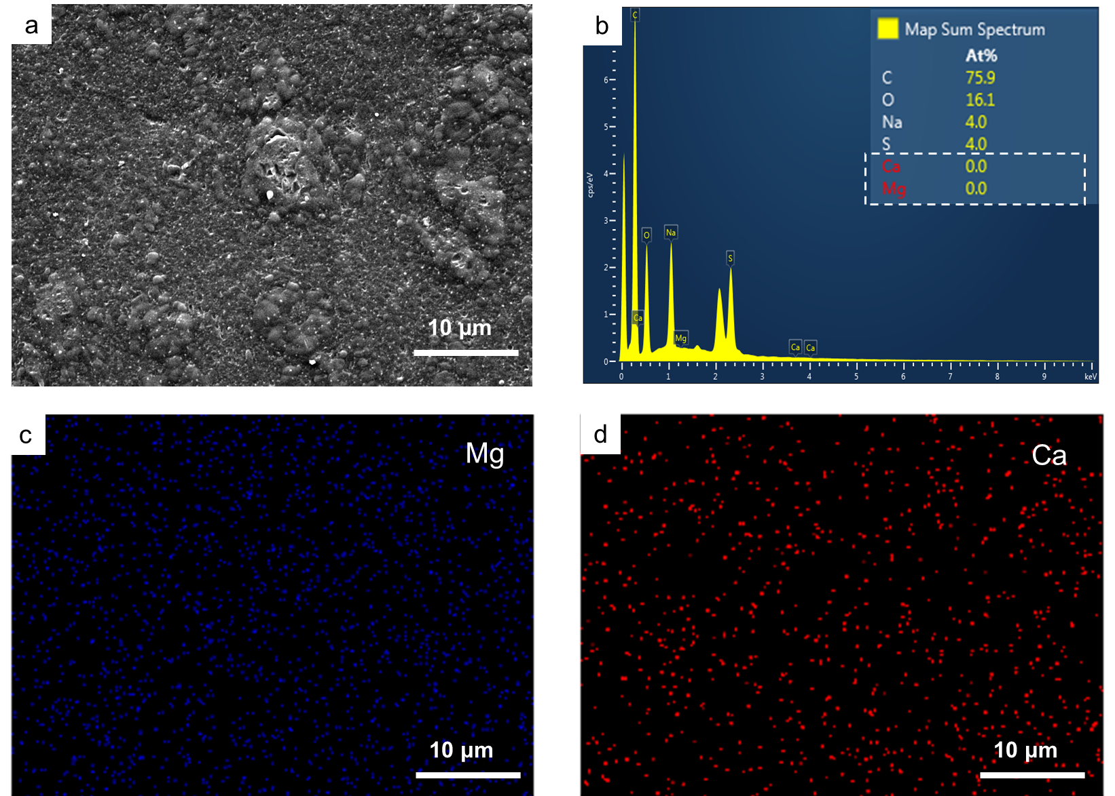

Figure S 1 Characterization of CEM (Conditions: feed solution = NaCl, current density = 15 mA/cm2, cell pairs = 3). (a) SEM graph; (b) EDS map spectrum; (c) EDS elemental mapping image of Mg; (d) EDS elemental mapping image of Ca.

* BMED treating SWB
  + Turbidity in chamber

Table S2 The turbidity [NTU] of solution in SWB and base chamber

|  |  |  |  |  |
| --- | --- | --- | --- | --- |
|  | BMED treating NaCl | | BMED treating SWB | |
|  | Base chamber | SWB chamber | Base chamber | SWB chamber |
| Initial | 0.112±0.014 | 0.233±0.011 | 0.112±0.014 | 0.137±0.021 |
| Final | 0.203±0.041 | 0.381±0.026 | 29.400±0.920 | 45.233±0.125 |

* Photo of membrane after experiment



Figure S2 The photo of membranes after test. BMED with CEM: (a1) AEM facing SWBC; (a2) CEM facing SWBC; (a3) CEM facing BC; (a4) BPM facing BC. BMED with SCEM: (b1) AEM facing SWBC; (b2) SCEM facing SWBC; (b3) SCEM facing BC; (b4) BPM facing BC.

* The composition of scaling

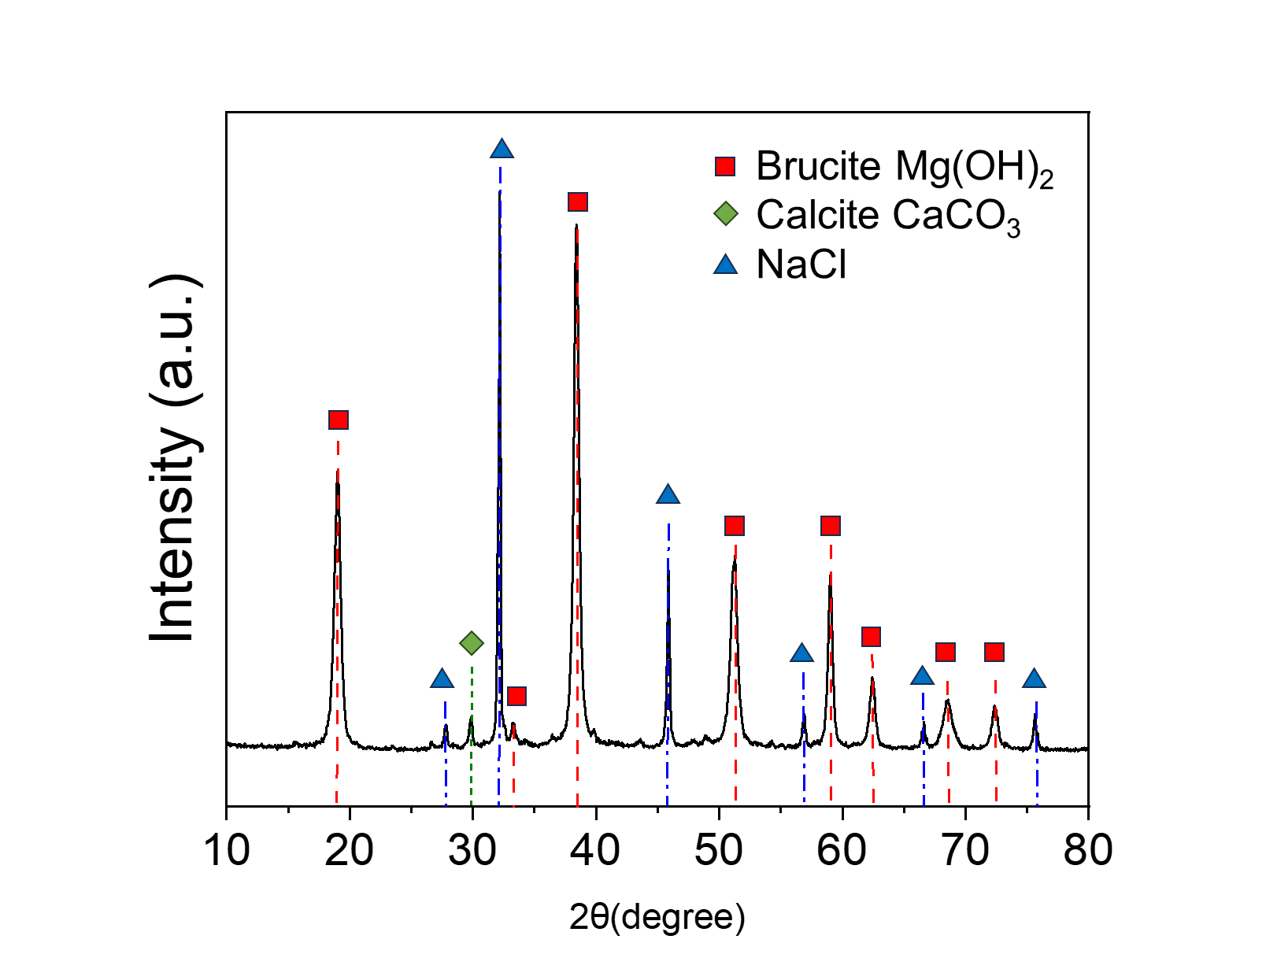

Figure S 3 X-ray diffraction spectra for the precipitates collected on membrane.

* + SEM&EDS of membrane surface and cross-section



Figure 2 SEM and EDS elemental analysis of membrane surfaces. AEM facing SWBC: (a1) SEM diagram; (a2) EDS elemental mapping image of Mg; (a3) EDS elemental mapping image of Ca; (a4) EDS map spectrum. CEM facing SWBC: (b1) SEM diagram; (b2) EDS elemental mapping image of Mg; (b3) EDS elemental mapping image of Ca; (b4) EDS map spectrum. CEM facing BC: (c1) SEM diagram; (c2) EDS elemental mapping image of Mg; (c3) EDS elemental mapping image of Ca; (c4) EDS map spectrum. BPM facing BC: (d1) SEM diagram; (d2) EDS elemental mapping image of Mg; (d3) EDS elemental mapping image of Ca; (d4) EDS map spectrum. (Conditions: Feed solution = seawater brine, current density = 15 mA/cm2, cell pairs = 3, membrane = CEM. SWBC: seawater brine chamber; BC: base chamber).

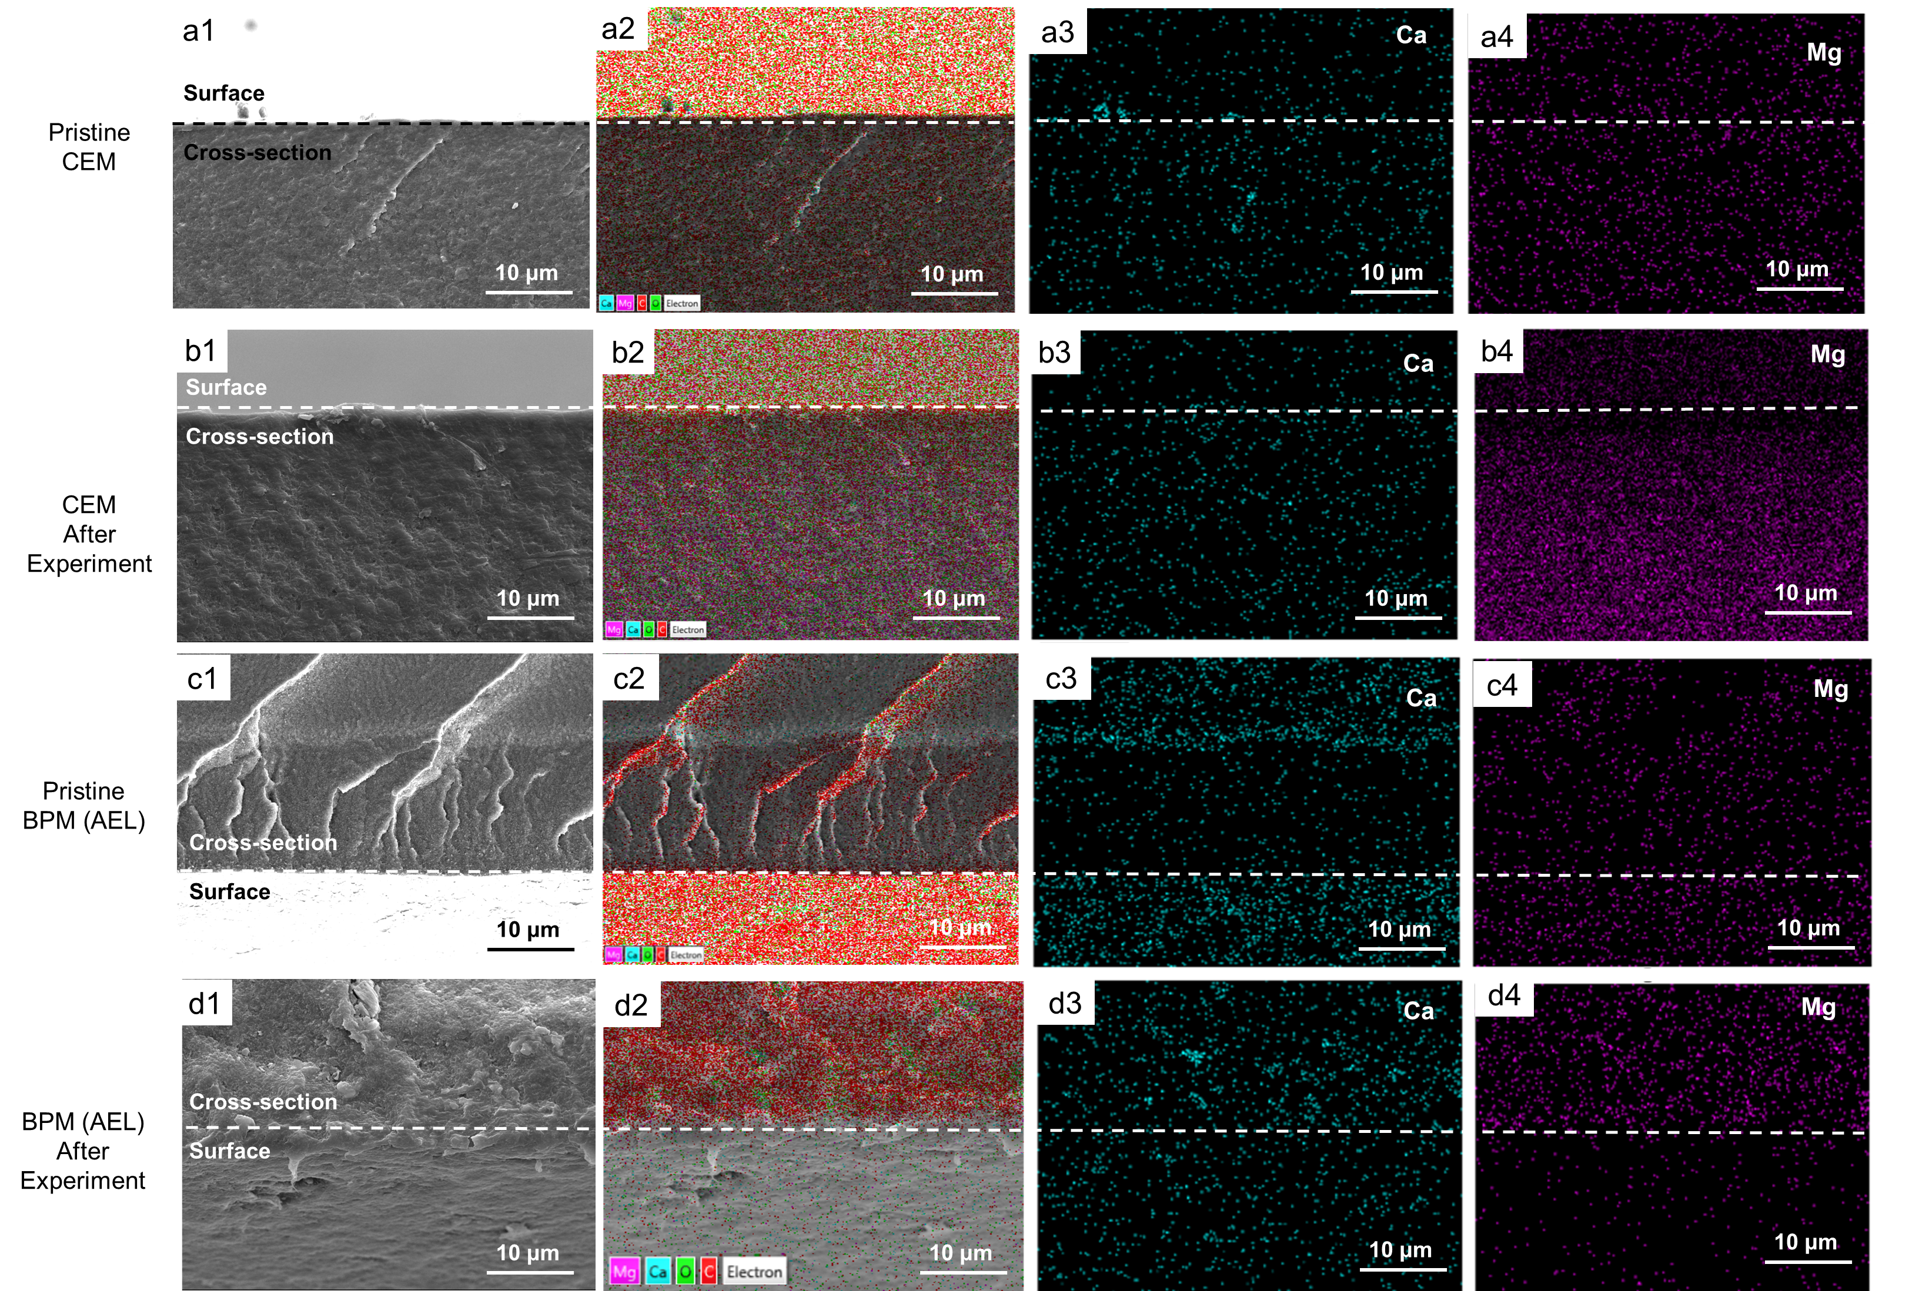

Figure 3 The SEM graph and EDS map spectrum of cross-section of membranes (White line is the dividing line of cross-section and membrane surface). Pristine CEM: (a1) SEM diagram; (a2) EDS map spectrum; (a3) EDS elemental mapping image of Ca; (a4) EDS elemental mapping image of Mg. CEM after experiment: (b1) SEM diagram; (b2) EDS map spectrum; (b3) EDS elemental mapping image of Ca; (b4) EDS elemental mapping image of Mg. Pristine BPM (AEL): (c1) SEM diagram; (c2) EDS map spectrum; (c3) EDS elemental mapping image of Ca; (c4) EDS elemental mapping image of Mg. BPM (AEL) after experiment: (d1) SEM diagram; (d2) EDS map spectrum; (d3) EDS elemental mapping image of Ca; (d4) EDS elemental mapping image of Mg. (Conditions: Feed solution = seawater brine, current density = 15 mA/cm2, cell pairs = 3, membrane = CEM).

* + SEM & EDS of crystal on CEM surface

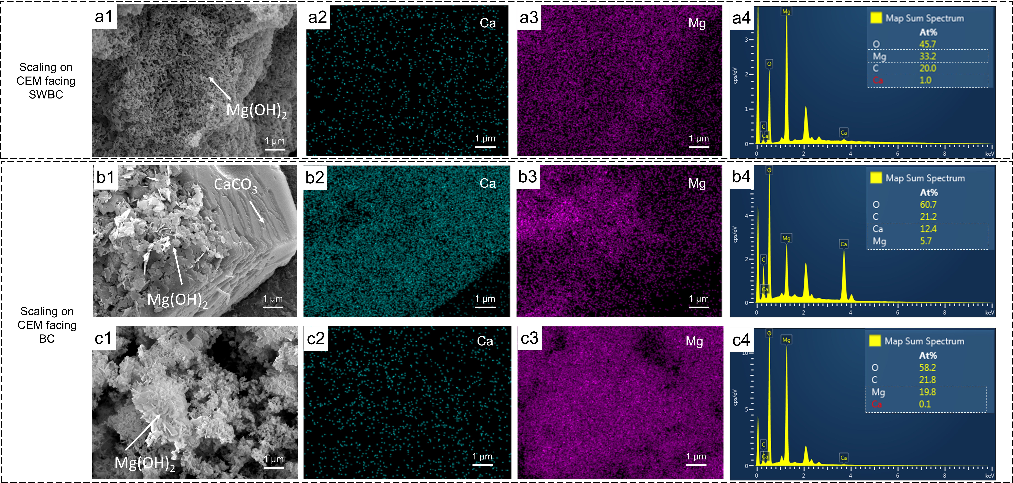

Figure S 4 The morphology of crystal on CEM facing SWBC: (a1) SEM diagram; (a2) EDS elemental mapping image of Ca; (a3) EDS elemental mapping image of Mg; (a4) EDS map spectrum. CEM facing BC: (b1) SEM diagram; (b2) EDS elemental mapping image of Ca; (b3) EDS elemental mapping image of Mg; (b4) EDS map spectrum.

* + The mechanism of scaling in BMED

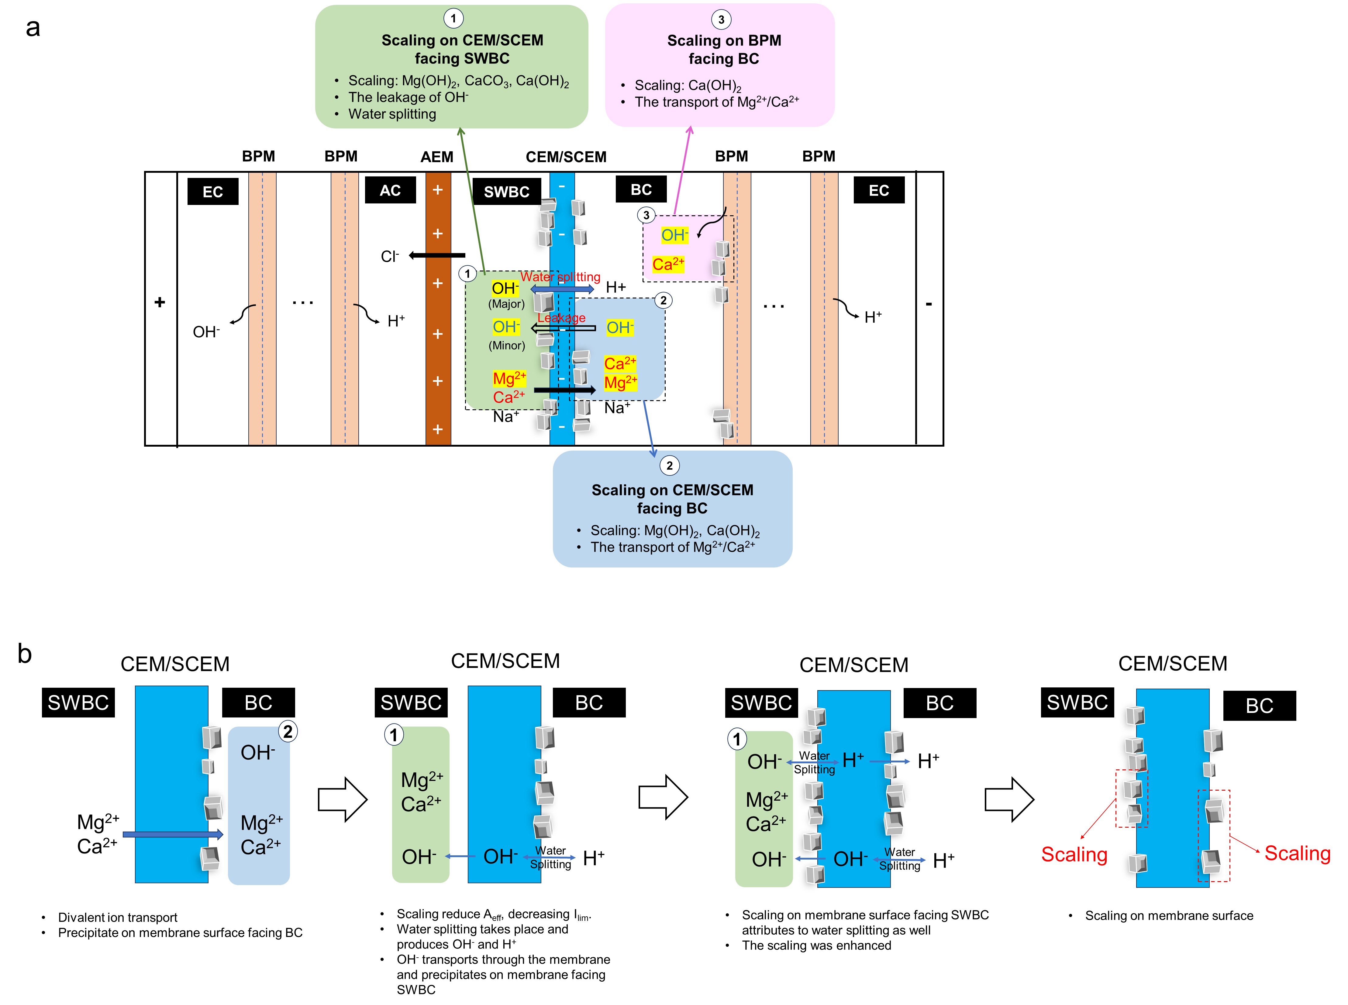

Figure 4 (a) Schematic illustration of mechanisms of scaling generation in BMED system (EC: electrode chamber; AC: acid chamber; SWBC: seawater brine chamber; BC: base chamber). (b) The procedure of scaling formation on both sides of CEM/SCEM due to water splitting. (Aeff = effective membrane area; Ilim = limiting current)

* + Quantification of scaling in BMED

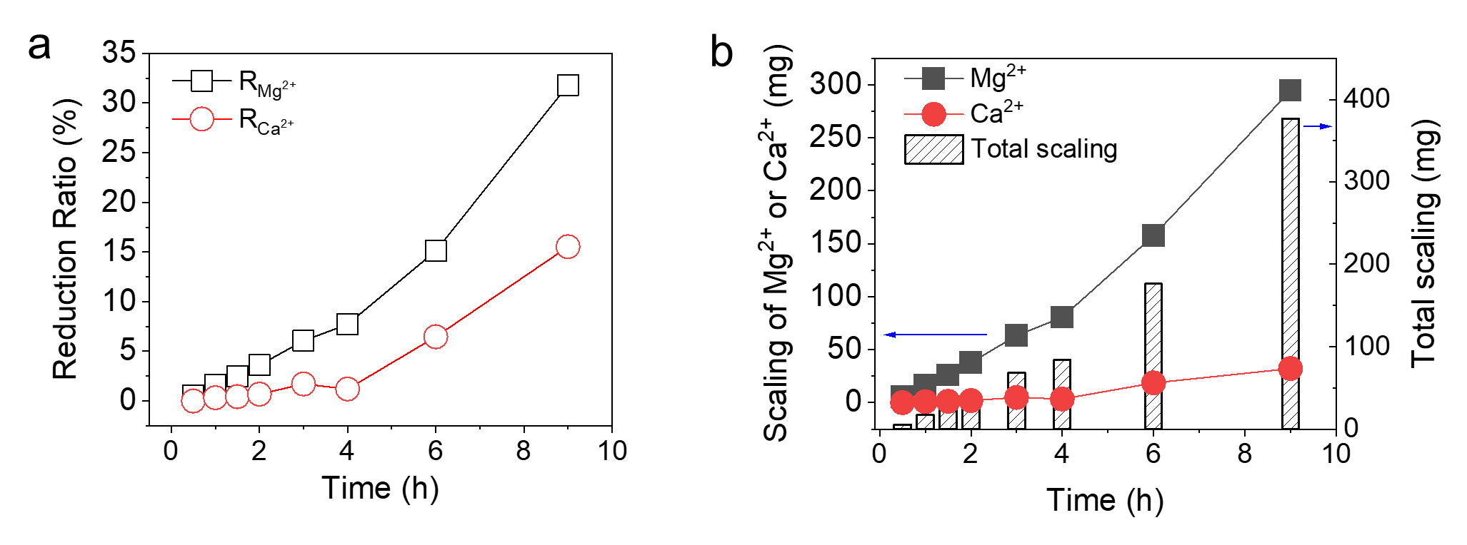

Figure 5 The concentration change of Mg2+ and Ca2+ with different membrane in (a1) acid, (a2) base, and (a3) SWB chamber and under different current densities in (b1) acid, (b2) base, and (b3) SWB chamber.

* + 1. **Effect of Scaling on BMED Performance**

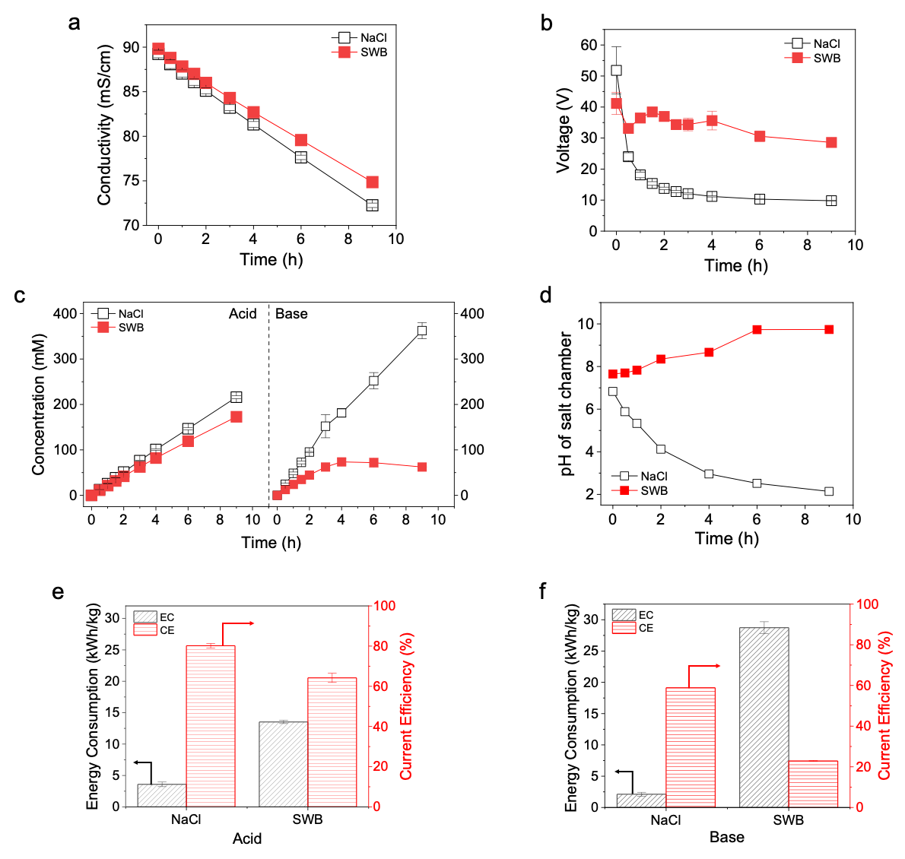

Figure 6(a) Conductivity changes in salt chamber and (b) Voltage changes in BMED system treating NaCl and SWB. (c) Concentration of generated acid and base with time. (d) pH change in the salt chamber. The current efficiency and energy consumption of the entire process to produce (e) acid and (f) base. (Conditions: Feed solution = NaCl or SWB, current density = 15 mA/cm2, cell pairs = 3, membrane = CEM)

* 1. **Effect of Mono-/di-valent selectivity of CEM** **on scaling**
  + **SEM & EDS of membrane surface**



Figure 7 SEM and EDS elemental analysis of membrane surfaces. AEM facing SWBC: (a1) SEM diagram; (a2) EDS elemental mapping image of Mg; (a3) EDS elemental mapping image of Ca; (a4) EDS map spectrum. SCEM facing SWBC: (b1) SEM diagram; (b2) EDS elemental mapping image of Mg; (b3) EDS elemental mapping image of Ca; (b4) EDS map spectrum. SCEM facing BC: (c1) SEM diagram; (c2) EDS elemental mapping image of Mg; (c3) EDS elemental mapping image of Ca; (c4) EDS map spectrum. BPM facing BC: (d1) SEM diagram; (d2) EDS elemental mapping image of Mg; (d3) EDS elemental mapping image of Ca; (d4) EDS map spectrum. (Conditions: Feed solution = seawater brine, current density = 15 mA/cm2, cell pairs = 3, membrane = SCEM. AC: acid chamber; SWBC: seawater brine chamber; BC: base chamber).

* + **Quantification of scaling**

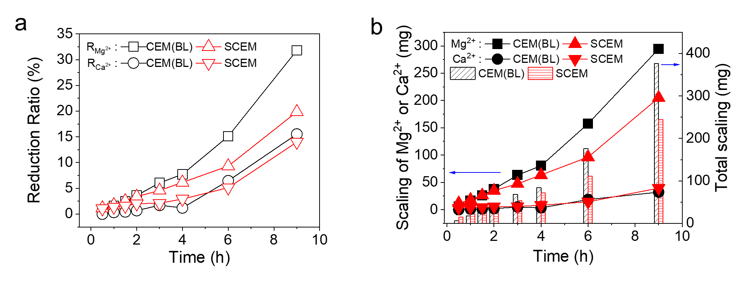

Figure 8 Quantification of scaling in BMED system. (a) Reduction ratio of Mg2+ and Ca2+ in BMED system treating SWB and (b) The amount of scaling in BMED system with different membrane stack. (Conditions: Feed solution = SWB, current density = 15 mA/cm2, cell pairs = 3, membrane = CEM (baseline, BL) and SCEM).

* + BMED performance

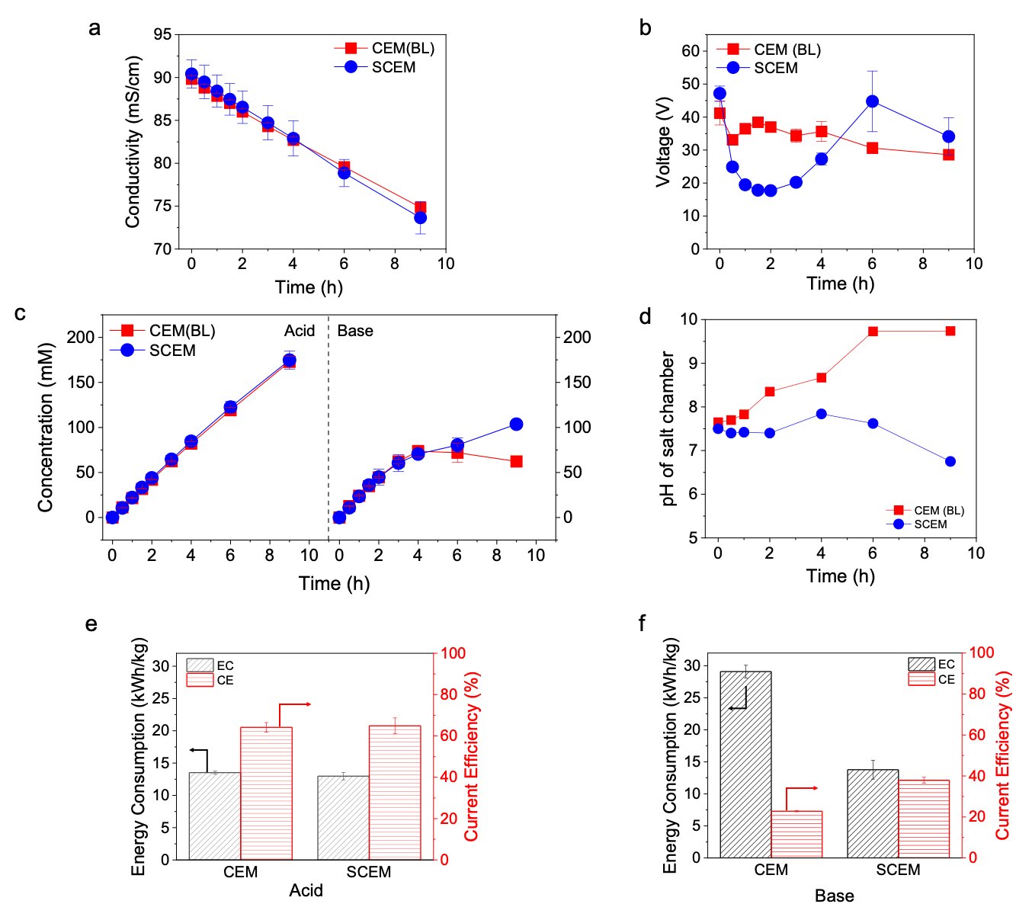

Figure 9 (a) Conductivity change in salt chamber and (b) Voltage change with different membrane stack. (c) Concentration of generated acid and base with different membrane stack. (d) pH change in the salt chamber. The current efficiency and energy consumption of the entire process to produce (e) acid and (f) base with different membrane stack. (Conditions: Feed solution = SWB, current density = 15 mA/cm2, cell pairs = 3, membrane = CEM (BL) and SCEM).

* 1. **Effect of current density on scaling**

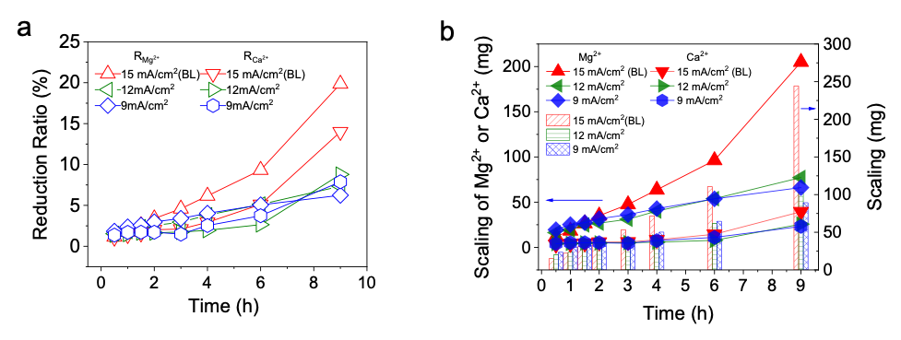

Figure 10 Quantification of scaling under different current. (a) Reduction ratio of Mg2+ and Ca2+ in BMED system treating SWB and (b) The amount of scaling in BMED system under different current density. (Conditions: Feed solution = SWB, cell pairs = 3, membrane = SCEM, current density = 15 (BL), 12 and 9 mA/cm2).



Figure 11 (a) Conductivity change in salt chamber and (b) Voltage change with time under different current density. (c) Concentration of generated acid and base under different current density. (d) pH change in the salt chamber. The current efficiency and energy consumption of the entire process to produce (e) acid and (f) base under different current density. (Conditions: Feed solution = SWB, cell pairs = 3, membrane = SCEM, current density = 15 (BL), 12 and 9 mA/cm2).

1. **Conclusion**

* The significance of reducing scaling with SIEMs
* Research result: optimal current density and initial concentration
* Future work

Supporting Information

1. **The concentration change in each chamber**



Fig. S5 The concentration change of Mg2+ and Ca2+ with different membrane in (a1) acid, (a2) base, and (a3) SWB chamber and under different current densities in (b1) acid, (b2) base, and (b3) SWB chamber.

1. The measurement of stack resistance

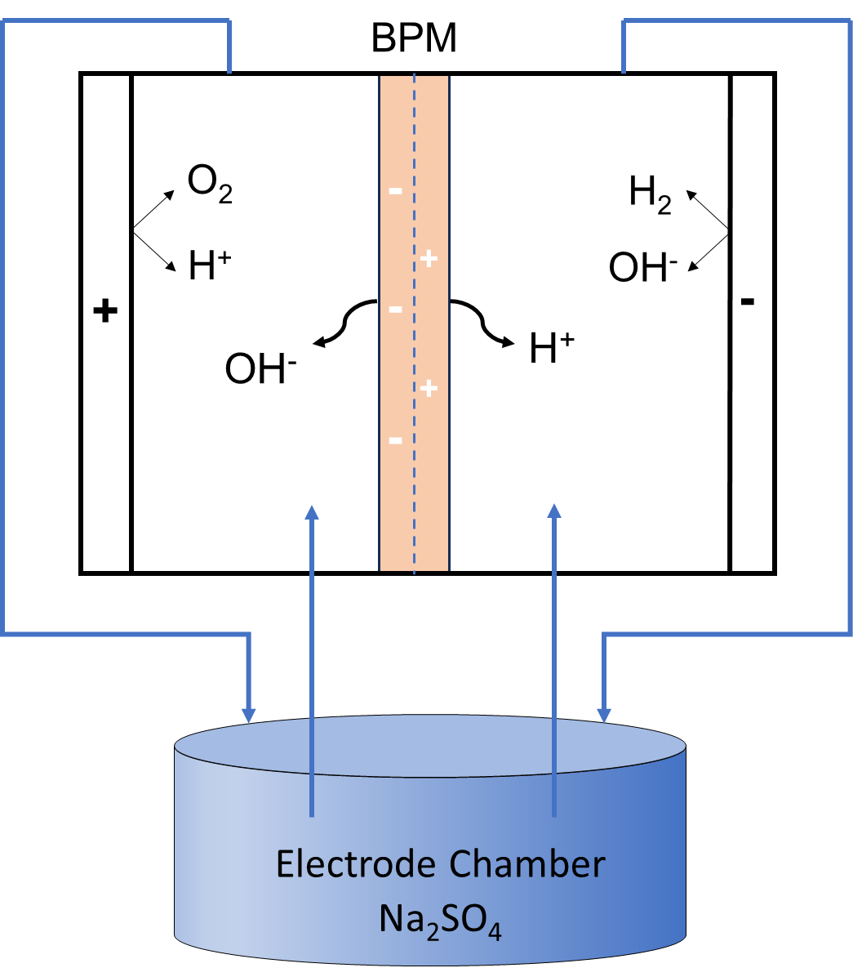

Figure S 6 Schematic experimental setup for determining the electrode resistance. (Conditions: electrode solution = 0.3 M Na2SO4, current density = 5~20 mA/cm2)

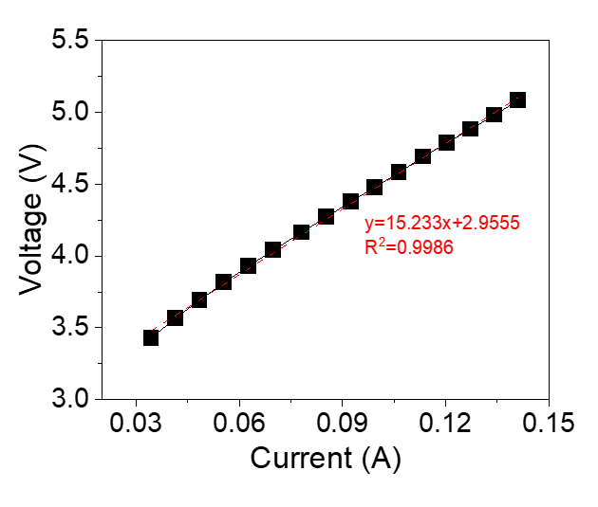

Figure S 7 Voltage drop of the electrode compartments as a function of direct current.



Figure S8. (a) The resistance change of membrane and chamber over time when treating NaCl or SWB. (b) The relationship between chamber resistance and total resistance in the BMED system during the treatment of SWB and NaCl solutions. (Conditions: Feed solution = NaCl or SWB, current density = 15 mA/cm2, cell pairs = 3, membrane = CEM) (c) The resistance change of membrane and chamber over time with difference membrane stack (Conditions: Feed solution = SWB, current density = 15 mA/cm2, cell pairs = 3, membrane = CEM or SCEM);(d) The resistance change of membrane and chamber over time under different current densities(Conditions: Feed solution = SWB, current density = 15, 12, 9 mA/cm2, cell pairs = 3, membrane = SCEM)



Fig. pH change in salt chamber to measure OH- leakage. Non-scaling group: Use NaCl as salt solution and run 3 hours. Change a new NaCl solution and run another 3 hours. Scaling group: Use SWB as salt solution and run 3 hours. Clean the membrane surface and replace SWB with NaCl. Run another 3 hours.